DAC LAB

NAME | USN | ROLL | DIVISION
Neha Chaudhary | 01fe18bec086 | 119 | B

NAME: NEHA CHAUDHARY
DIVISION: B

Experiment 1

1.a.1Title of the experiment: Voltage series feedback amplifier and Voltage shunt feedback amplifier using op-amp with a gain of 11

1.a.2 Objective of the experiment:
a. To design and Implement a Voltage series feedback amplifier with op-amp gain of 11.
Determine
- Gain
- Bandwidth
- Input impedance
- Output impedance
- Maximum output voltage swing
- Configure the given op-amp as a voltage follower and obtain all the above parameters
- Design and implement a voltage shunt feedback amplifier using a suitable simulation to with a gain of 10
Determine
- Gain
- Bandwidth
- Input impedance
- Output impedance
- Maximum output voltage swing
Compare the observed parameters of voltage series feedback amplifier with voltage shunt feedback amplifier and draw the interference from the observation.

1.a.3 Components Used:
Sl.No | Components/Equipment | Specifications | Quantity
1 | Regulated DC | 0-30V, 2A | 02
2 | CRO | 80 V_{pp}/20MHz | 01
4 | +12V and -12V Power pack |  | 01
5 | Op-Amplifier | µA-741 | 01
6 | Resistor | 3.3K ½ watt  1K ½ watt  10K ½ watt | 02  01  01
7 | BNC Probes |  | 02

1.a.4 Experimental Setup:

Voltage Series Feedback Amplifier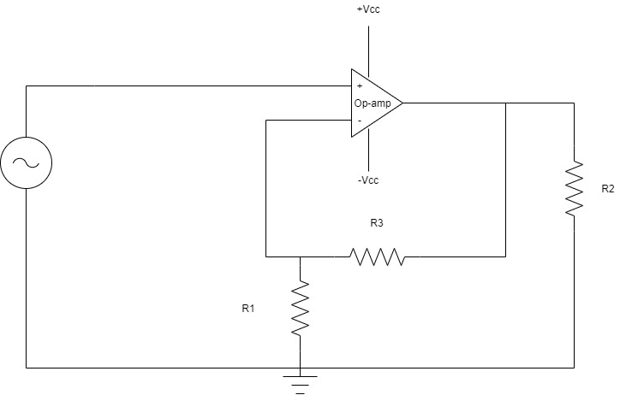

Voltage Shunt Feedback Amplifier
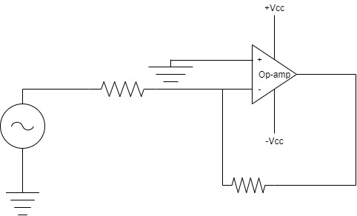

1.a.5 Theoretical Background:

When any increase in the output signal results into the input in such a way as to cause the decrease in the output signal, the amplifier is said to have negative feedback. The advantages of providing negative feedback are that the transfer gain of the amplifier with feedback can be stabilized against variations in the hybrid parameters of the transistor or the parameters of the other active devices used in the circuit. The most advantage of the negative feedback is that by proper use of this, there is significant improvement in the frequency response and in the linearity of the operation of the amplifier. This disadvantage of the negative feedback is that the voltage gain is decreased. In Voltage-Series feedback, the input impedance of the amplifier is increased and the output impedance is decreased. Noise and distortions are reduced considerably.

1.a.6 Formulae Required:
Gain: A_{f} = A/(1+Aβ)
A – Closed Loop gain of the amplifier
β – Feedback Factor
Bandwidth:
Input Impedance: R1 || R3
Output Impedance: R2
Maximum Output Voltage Swing: NA (Input to Saturation)

1.a.7 Step by Step procedure to carry out experiment:
- Electrical connections are made as shown in the circuit diagram.
- Observe the frequency, voltage of the output wave on CRO.
- Carry out the required calculations
1.a.8 Table of Observations
1.a.9 Specimen Calculation
Given: A = 11
For, Voltage Series Feedback Amplifier
Let us assume A_{f} = 3
A_{f}= A/(1 + Aβ)
- β = 8/33 = 0.24

- WKT, β = R₁/(R₁ + R₃)
- R3/R1 = 3.15

- R1 = 1KΩ, R3 = 3.15KΩ (= 3.3K)
- Bandwidth: 1hz – 20Khz
- Input Impedance: R1 || R3 = 0.75KΩ
- Output Impedance: R2 (check circuit diagram) = 10KΩ
- Maximum Output Voltage Swing: 0V – 15V

For Voltage Series Feedback Amplifier in Voltage Follower Configuration
A_{f} = 1
- β = 0.9
- WKT, β = R₁/(R₁ + R₃)
- R3/R1 = 1/9 = 0.11
- R1 = 9KΩ (= 10K), R3 = 1KΩ
- Gain = 1
- Bandwidth: 1hz – 20Khz
- Input Impedance: R1 || R3 = 0.9KΩ
- Output Impedance: R2 = 10K
- Maximum Output Voltage Swing: 0V – 15V

For Voltage Shunt Feedback Amplifier
Let us assume A_{f} = 11
A_{f} = -AK/(1+Aβ)
K = R_{f}/(R₁ + R_{f}), β = R₁/(R₁ + R_{f})
- R1 = 1KΩ, Rf = 11KΩ, β = 0.083
- Gain = 3
- Bandwidth: 1hz – 20Khz
- Input Impedance: R1 || Rf = 0.91KΩ
- Output Impedance: R2 = 10KΩ

- Maximum Output Voltage Swing: 0V – 15V

1.a.10 Nature of graph:

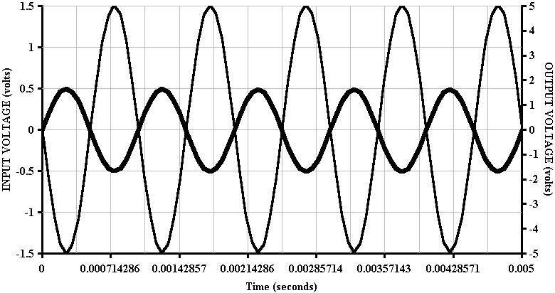
Voltage-Shunt Feedback Amplifier

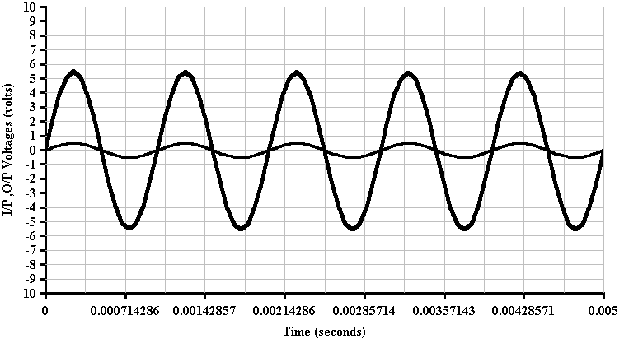
Voltage –Series Feedback Amplifier
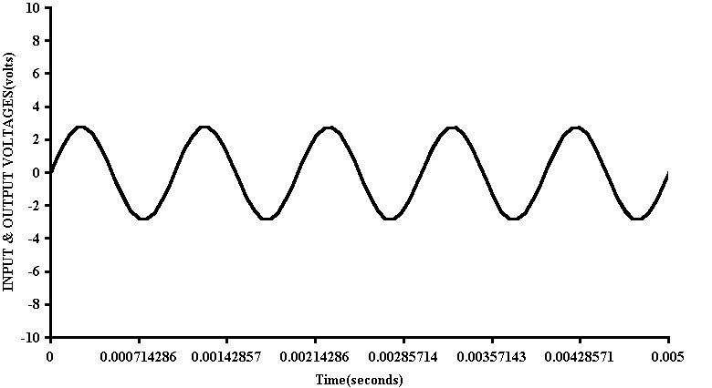
Voltage Follower

1.a.11 Circuit Diagram from the tool:

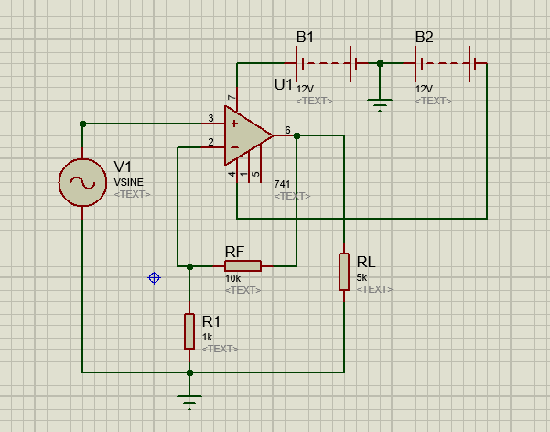
Voltage –Series Feedback Amplifier
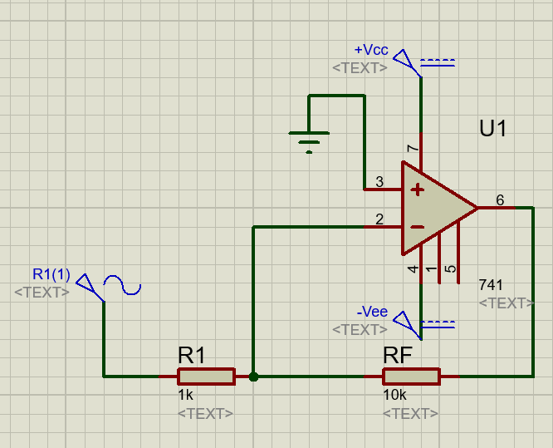
Voltage –Shunt Feedback Amplifier

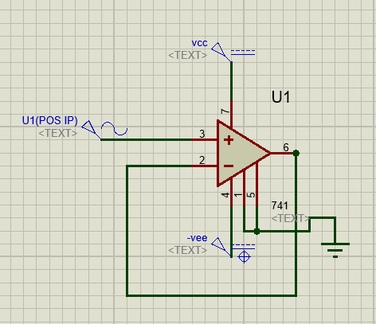
Voltage Follower
1.a.12 Output obtained from the tool:

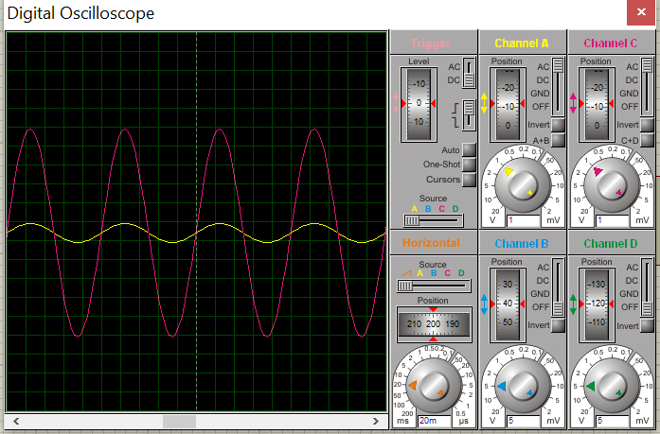
Voltage –Series Feedback Amplifier

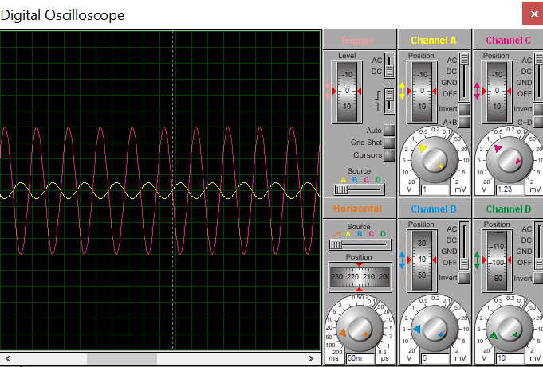
Voltage-Shunt Feedback Amplifier

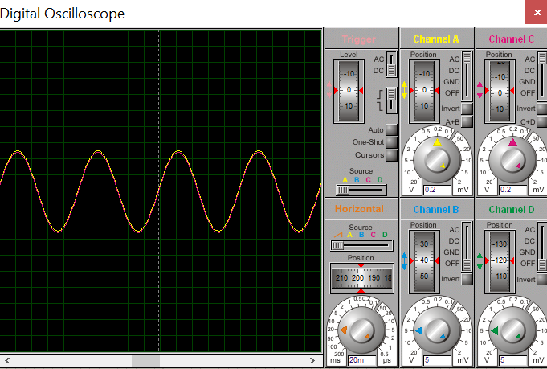
Voltage Follower

1.a.13 Conclusion:
After carrying out the experiment it can be concluded that, The Voltage Series Feedback Amplifier, the feedback is applied in series with the input voltage and in Voltage Shunt Feedback Amplifier, the feedback is applied in parallel with the input voltage.

Voltage Series Feedback Amplifier: As the feedback circuit is connected in shunt with the output, the output impedance is decreased and due to the series connection with the input, the input impedance is increased.

Voltage Shunt Feedback Amplifier: As the feedback circuit is connected in shunt with the output and the input as well, both the output impedance and the input impedance are decreased.

Experiment 2
2.a.1 Title of the Experiment: Instrumentation Amplifier

2.a.2 Objective of the Experiment: To design a signalconditioning with input buffer stage, intended to amplify a low-level signal in µV’s range proportional to the change in physical quantity being measured

2.a.3 List of Component / Equipment:

Sl.No | Item | Specification | Quantity
1. | IC | UA 741 | 03
2 | DMM | 500V/10A/200mA | 03
3. | DC Power supply | 0 – 30 V, 2A | 01
4. | Op-amp | µA-141 | 01
5. | BNC |  | 02

2.a.4 Experimental setup:

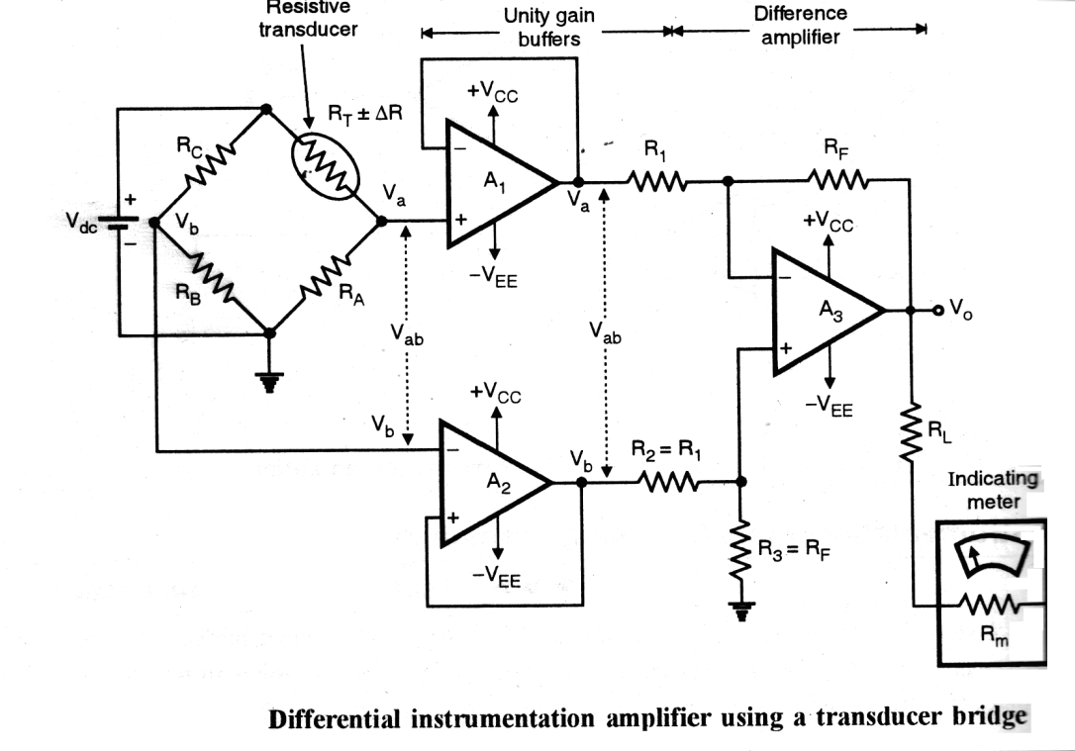
2.a.5 Theoretical background for the experiment/validation of the experiment:
This is a high impedance amplifier using cross-coupled difference amplifiers. A₁& A₂ in the above figure are non-inverting amplifiers. As all the OPAMPS are assumed to have infinite Z_{i} ,theiri/p current is zero
Instrumentation Amplifier is no ordinary Op-amp circuit, it is designed to serve a specific purpose and does so with high precision. It acts as a signal conditioning circuit. The sensor that gets the data of mechanical quantities can be translated into a variable resistor, which can be seen in the wheat-stone bridge. Further the buffer instrumentation amplifier setup gives the output voltage and error can be calculated.

2.a.6 Formulae-required:
Voltage Gain = -Rf/R1 (A3)
Let required gain be 10.
Assume R1=1kΩ
Therefore Rf=10kΩ.
Overall gain of the instrumentation amplifier is
---------- (10)
Hence by varying R₂, the overall gain can be linearly varied.
Output voltage, ---------- (11)

2.a.7 Step by step procedure to carry out experiment:
- Electrical connections are made as shown in the circuit diagram.
- Select the gain and obtain the desired components.
- Select the signal from the function generator to be amplified
- Note down the output from the DMM.

2.a.8 Table of observation:

Observation No | V=V_{a} -V_{b} | Vo | V_{cal} | Error
1 | 0.01 | 0.11 | 0.1 | 0.01
2 | 0.02 | 0.2 | 0.2 | 0.00
3 | 0.04 | 0.42 | 0.4 | 0.02
4 | 0.09 | 0.88 | 0.9 | -0.02
5 | 0.11 | 1.2 | 1.1 | 0.01
6 | 0.2 | 1.89 | 2 | -0.01
7 | 0.25 | 2.52 | 2.5 | 0.02
8 | 0.47 | 4.71 | 4.7 | 0.01

2.a.9 Specimen calculation: --------- Not Applicable ---------

2.a.10 Nature of graph: N/A

2.a.11Circuit diagram from the tool:
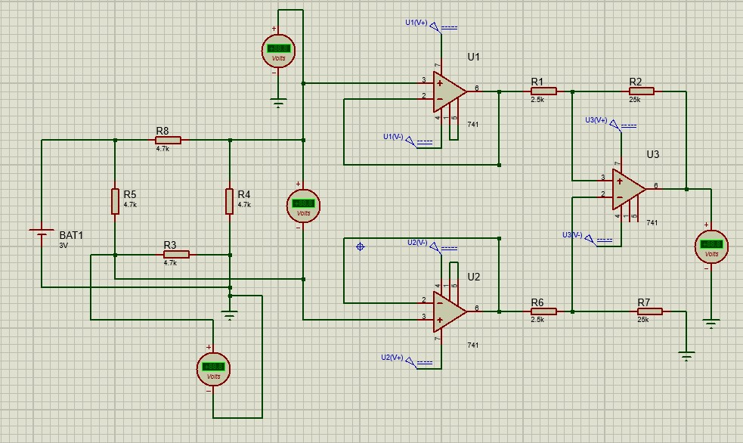

2.a.12 Output waveforms obtained from the simulation tool:
-----------------------

2.a.11 Conclusion of the experiment:The above setup is implemented and the output has been properly achieved. The input was amplified to desired value with high precision.

Experiment No: 3
3.a.1 Title of the Experiment: Low Pass Filters.(Second Order)

3.a.2 Objective of the Experiment:To design and implement a frequency selective network using a suitable simulation tool for the following specifications
Closed loop gain= 1.586
Cutoff frequency= 10KHz
Output voltage swing= +/- 11V
Voltage supply= +/- 12V
Roll of rate = -40 dB/decade
Use an operational amplifier having following specification
Input impedance =2MHz

Output impedance=75 ohms
UGB= 1MHz

3.a.3 List of Component / Equipments:

Sl.No | Components/Equipments | Specifications | Quantity
1 | Regulated DC | 0-30V, 2A | 02
2 | CRO | 80 Vpp/20MHz | 01
3 | +12V and -12V power pack |  | 01
4 | Op-Amplifier | µA-741 | 01
5 | Resistor | 1.5K ½ watt  1.7K½ watt  1K ½ watt | 02  01  01
6 | Capacitors | 0.01uF | 02
7 | BNC Probes |  | 02

a

3.a.4 Experimental setup:
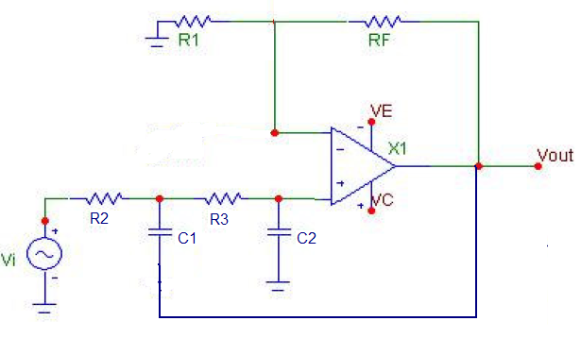

LowPass Filter (2nd Order)

R2=R3=R, C1=C2=C.

3.a.5 Theoretical background for the experiment/validation of the experiment:
A low-pass filter (LPF) is a filter that passes signals with a frequency lower than a selected cutoff frequency and attenuates signals with frequencies higher than the cutoff frequency. The exact frequency response of the filter depends on thefilter design. The filter is sometimes called a high-cut filter, or treble-cut filter in audio applications. A low-pass filter is the complement of a high pass filter.

3.a.6 Formulae-required:
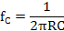
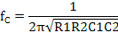

R1=R2=R, C1=C2=C.

3.a.7 Step by step procedure to carry out experiment:
- Electrical connections are made as shown in the circuit diagram.
- Increase the input frequency from 100 Hz to 10KHz slowly and after increase rapidly keeping input voltage constant.
- Note down the output gain.

3.a.8 Table of observation:Vi = 1V

Observation No | Input Frequency (fi) in Hz | Output Voltage ‘V0’(V) | Gain= V0/Vi | Gain In dB
1 | 100 | 1.5 | 1.5 | 3.52
2 | 500 | 1.5 | 1.5 | 3.52
3 | 1K | 1.5 | 1.5 | 3.52
4 | 2K | 1.5 | 1.5 | 3.52
5 | 5K | 1.5 | 1.5 | 3.52
6 | 7K | 1.5 | 1.5 | 3.52
7 | 10K | 1.5 | 1.5 | 3.52
8 | 15K | 1.2 | 1.2 | 1.58
9 | 20K | 0.6 | 0.6 | -4.4
10 | 25K | 0.4 | 0.4 | -7.9
11 | 50K | 0.08 | 0.08 | -21.9
12 | 100K | 0.01 | 0.01 | -40

3.a.9 Specimen calculation:
R=1.5K ohms, let C=0.01uF
therefore, fc=10KHz.

Gain= 1+Rf/R1, let R1=1.7K, Rf=1K
therefore Gain=1.586.

Bandwidth: Fl=0
Fh=fc=10KHz

3.a.10 Nature of graph:

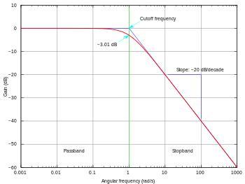
LowPass Filter Response

3.a.11 Circuit diagram from the tool:

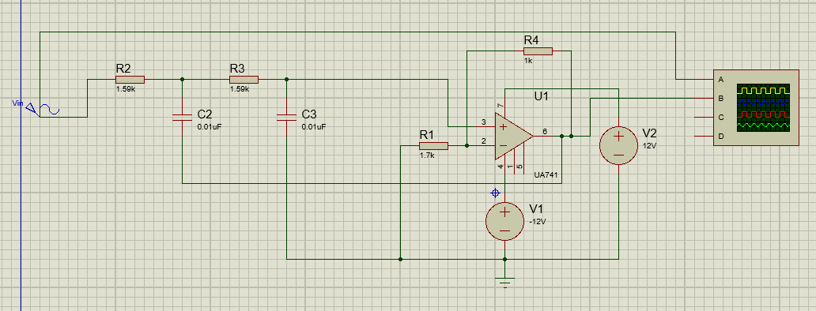

3.a.12 Output waveforms obtained from the simulation tool:

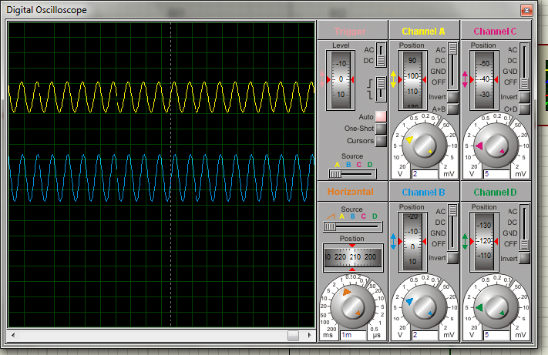

3.a.13 Conclusion of the experiment:
In this low pass filter, the frequencies above fc are attenuated and the frequencies below fc=10KHz are passed and the gain remains constanttill cut off frequency fc, above fc the gain decreases.

3.b.1 Title of the Experiment: High Pass Filters.(Second Order)

3.b.2 Objective of the Experiment: To design and implement a frequency selective network using a suitable simulation tool for the following specifications
Closed loop gain= 1.586
Cutoff frequency= 8KHz
Output voltage swing= +/- 11V
Voltage supply= +/- 12V
Roll of rate = +40 dB/decade
Use an operational amplifier having following specification

Input impedance =2MHz
Output impedance=75 ohms
UGB= 1MHz

3.b.3 List of Component / Equipments:

Sl. No | Components/ Equipments | Specifications | Quantity
1 | Regulated DC | 0-30V, 2A | 02
2 | CRO | 80 Vpp/20MHz | 01
3 | +12V and -12V power pack |  | 01
4 | Op-Amplifier | µA-741 | 01
5 | Resistor | 2K ½ watt  1.7K½ watt  1K ½ watt | 02  01  01
6 | Capacitors | 0.01uF | 02
7 | BNC Probes |  | 02

a

3.b.4 Experimental setup:

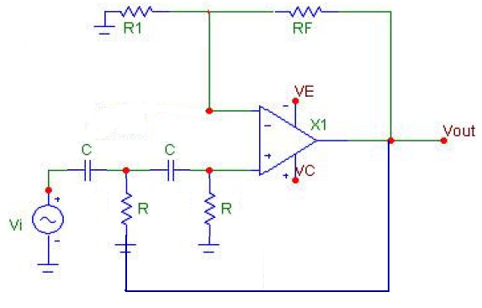
High Pass filter (2nd Order)

3.b.5 Theoretical background for the experiment/validation of the experiment:
A high-pass filter (HPF) is an electronic filter that passes signals with a frequency higher than a certain cutoff frequency and attenuates signals with frequencies lower than the cutoff frequency. The amount of attenuation for each frequency depends on the filter design. A high-pass filter is usually modeled as a linear time-invariant system. It is sometimes called a low-cut filter or bass-cut filter. High-pass filters have many uses, such as blocking DC from circuitry sensitive to non-zero average voltages or radio frequency devices. They can also be used in conjunction with a low-pass filter to produce a bandpass filter.

3.b.6 Formulae-required:

R1=R2=R, C1=C2=C.

3.b.7 Step by step procedure to carry out experiment:
- Electrical connections are made as shown in the circuit diagram.

- Increase the input frequency rapidly till 8KHz after increase slowly keeping input voltage constant.
- Note down the output gain.
3.b.8 Table of observation: Vi = 1V

Observation No | Input Frequency (fi) in Hz | Output Voltage ‘V0’ (V) | Gain= V0/Vi | Gain In dB
1 | 100 | 0 | 0 | 0
2 | 500 | 0.01 | 0.01 | -40
3 | 1K | 0.02 | 0.02 | -33.9
4 | 2K | 0.1 | 0.1 | -20
5 | 5K | 0.8 | 0.8 | -1.9
6 | 7K | 1.2 | 1.2 | 1.58
7 | 8K | 1.5 | 1.5 | 3.52
8 | 10K | 1.5 | 1.5 | 3.52
9 | 12K | 1.5 | 1.5 | 3.52
10 | 14K | 1.5 | 1.5 | 3.52
11 | 15K | 1.5 | 1.5 | 3.52
12 | 20K | 1.5 | 1.5 | 3.52

3.b.9 Specimen calculation:

R=2K ohms, let C=0.01uF
therefore, fc=8KHz.

Gain= 1+Rf/R1, let R1=1.7K, Rf=1K
therefore Gain=1.586.

Bandwidth: Fl=fc=8KHz

3.b.10 Nature of graph:
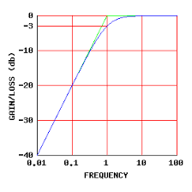
High Pass Filter Response

3.b.11 Circuit diagram from the tool:
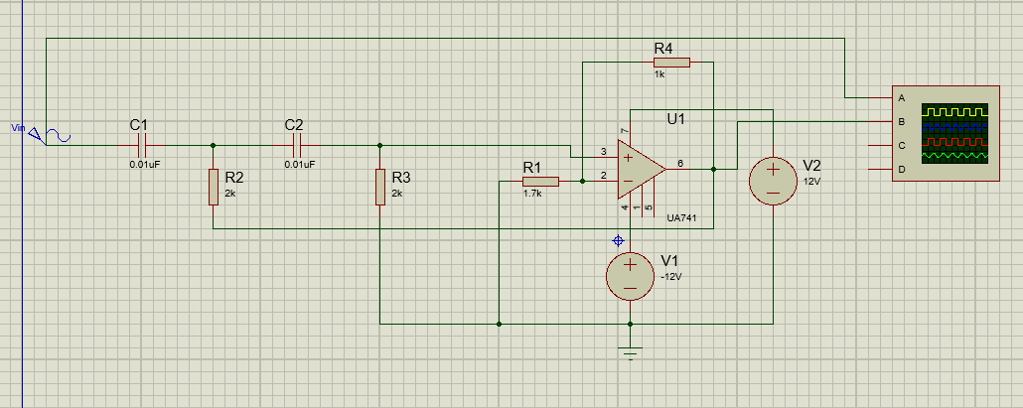

3.b.12 Output waveforms obtained from the simulation tool:
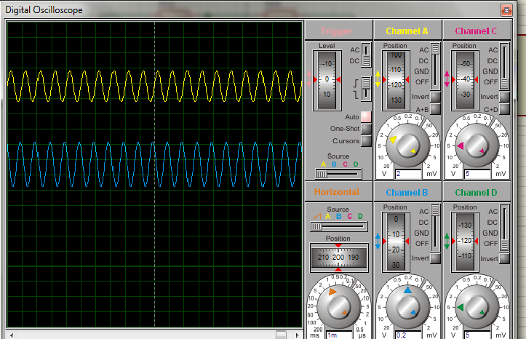

3.b.13 Conclusion of the experiment:
In this high pass filter, the frequencies below fc are attenuated and the frequencies above fc=8KHz are passed and the gain increases till fc and then remains constant.

Experiment No: 4
4.a.1 Title of the Experiment:
Data Converters.
4.a.2 Objective of the Experiment:
a. To implement circuit to obtain corresponding analog value of the following data using(10110)₂ using operational amplifier.
Rig up the circuit in simulation tool to determine

- A tabular column representing analog values for all the digital equivalent combinations.
- Resolution of the circuit under implementations.
- Represent the relationship between digital and analog values
Given reference voltage V_{ref} = 5V
Power supply =±12V.

b. To implement a 3 bit flash ADC using a suitable simulation tool
Rig up the circuit to obtain all the digital representations of the analog input values.
V_{ref}= 8V.

4.a.3 List of Component / Equipments:
Sl.No | Components/Equipments | Specifications | Quantity
1 | Regulated DC | 5V and +/- 12V | 02
2 | DMM | 500V/10A/200mA | 01
3 | Op-Amplifier | µA-141 | 01
4 | Resistor | 2K ½ watt CFR  1K ½ watt CFR | 07  04
5 | LED’s | --------- | 04

4.a.4 Experimental setup:

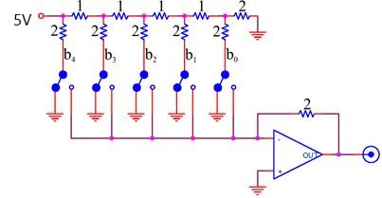
Digital To Analog Converter

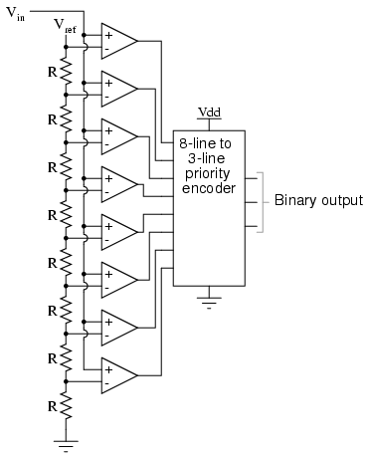
Analog To Digital Converter
4.a.5Theoretical background for the experiment/validation of the experiment:

A digital to analog converteris used when a binary output from a digital system must be converted to equivalent analog voltage or current. A DAC converter uses an op-amp and binary weighted resistors or R-2r ladder resistors. In binary weighted resistors method are used. This can be avoided by using R-2R ladder type DAC where only 2 values of resistors are required .The binary inputs are simulated by switches B0-B3 and output is proportional to the binary inputs. Binary inputs can be high (+5V) or low (0V).
Flash ADCalso called the parallel A/D converter, this circuit is the simplest to understand. It is formed of a series of comparators, each one comparing the input signal to a unique reference voltage. The comparator outputs connect to the inputs of a priority encoder circuit, which then produces a binary output.
V_{ref} is a stable reference voltage provided by a precision voltage regulator as part of the converter circuit, not shown in the schematic. As the analog input voltage exceeds the reference voltage at each comparator, the comparator outputs will sequentially saturate to a high state. The priority encoder generates a binary number based on the highest-order active input, ignoring all other active inputs.
4.a.6 Formulae-required:

$Vo=\frac{Rf*Vref}{R}[\frac{b4}{2}+\frac{b3}{4}+\frac{b2}{8}+\frac{b1}{16}+\frac{b0}{32}$]

4.a.7 Step by step procedure to carry out experiment:
Digital to Analog
- Electrical connections are made as shown in the circuit diagram.
- To make any one bits high, we connect corresponding switch to 5V reference voltage & to make any one of the bits low connect the corresponding switch to ground.
- For all the combinations of 0’s & 1’s i.e. (00000 to 11111) the output voltage is noted down.
- Calculate the error between theoretical o/p voltage & observed voltage.

Analog To Digital
- Circuit connections are made as per the circuit diagram.
- Give Vin and Vref voltages.
- Check the binary output by giving different Vin values.

4.a.8 Table of observation:

4.a.9 Specimen calculation: NA
4.a.10 Nature of graph: NA
4.a.11 Circuit diagram from the tool:

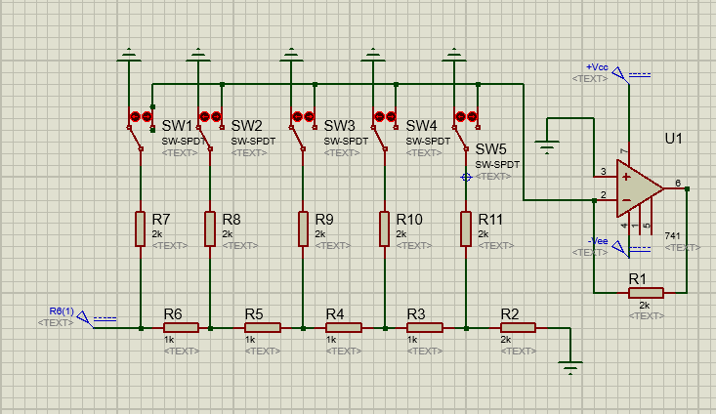
Digital to Analog Converter
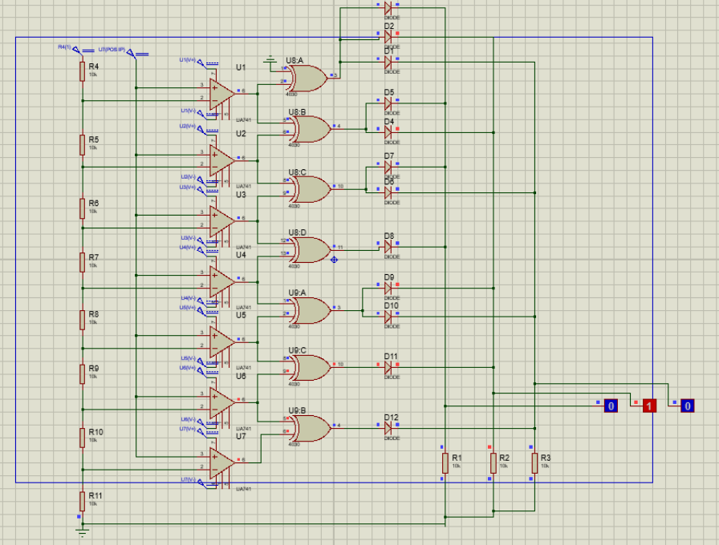
Analog to Digital Converter

4. a.12 Output waveforms obtained from the simulation tool: NA

4.a.13 Conclusion of the experiment:

The above data converters are simulated and the output is obtained according to the requirements.

Experiment No: 5
5.a.1 Title of the Experiment: Schmitt trigger circuit

5.a.2 Objective of the Experiment: To Design and implement a circuit to obtain the following transfer function
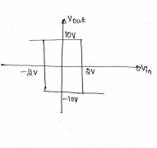
Power supply=±12V.
- Obtain the output waveform
- Output voltage swing

5. a. 3 List of Component / Equipments:

Sl.No | Components/Equipments | Specifications | Quantity
1 | Regulated DC | 0-30V, 2A | 02
2 | CRO | 80 Vpp/20MHz | 01
4 | +12V and -12V power pack |  | 01
5 | Op-Amplifier | µA-741 | 01
6 | Resistor | 3.3K ½ watt  660E ½ watt  1K ½ watt | 01  01  01
8 | BNC Probes |  | 02

a

5.a.4 Experimental setup:
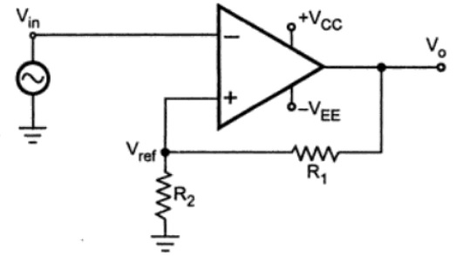
5.a.5 Theoretical background for the experiment/validation of the experiment:
The Schmitt Trigger is a logic input type that provides hysteresis or two different threshold voltage levels for rising and falling edge. This is useful because it can avoid the errors when we have noisy input signals from which we want to get square wave signals.
So for example, if we have a noisy input signal, that is meant to have 2 pulses, a device that has only one set point, or threshold, could get incorrect input and it could register more than two pulses as shown in this illustration. And if we use the Schmitt Trigger for the same input signal we will get a correct input of two pulses because of the two different thresholds. So that’s the primal function of the Schmitt Trigger, to convert noisy square waves, sine waves or slow edges inputs into clean square waves.

5.a.6 Formulae-required:
V_{utp}=R1 x V_{sat}/(R1+R2)
V_{ltp}=-R1 x V_{sat}/(R1+R2)

5.a.7 Step by step procedure to carry out experiment:
- Electrical connections are made as shown in the circuit diagram.
- Give the input sine wave from the inverting pin

- Output should be in the form of a square wave, its magnitude depends on the resistors R1 and R2 and it can be estimated using the formulae.
5.a.8 Table of observation:

Vin | Frequency | Vutp | Vltp
2V | 1KHz | 10V | -10V
2.5V | 1KHz | 10V | -10V
3V | 1KHz | 10V | -10V

5. a.9 Specimen calculation:
V_{utp}=R1 x V_{sat}/(R1+R2)
V_{ltp}=-R1 x V_{sat}/(R1+R2)

Assume R1=1Kohms Vsat=10V and Vutp=-Vltp=2V
Therefore, R2=4kohms

5.a.10 Nature of graph:
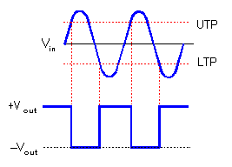

5.a.11 Circuit diagram from the tool:

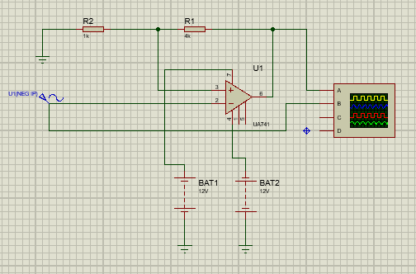

5.a.12 Output waveforms obtained from the simulation tool:
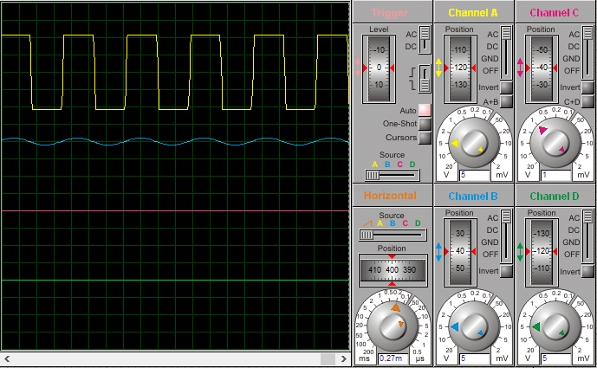

5.a.13 Conclusion of the experiment:
The output obtained is a square wave with the voltage swing of 20V (10V to -10V) which meets the nature of the graph.

5.b.1 Title of the Experiment: Zero Crossing detector

5.b.2 Objective of the Experiment:
Implement a circuit in an open loop configuration to convert any given input signal to a square wave
- List the applications of the following circuits
- Explain the disadvantages of the circuit and provide a suitable solution
5.b.3 List of Component / Equipments:

Sl.No | Components/Equipments | Specifications | Quantity
1 | Regulated DC | 0-30V, 2A | 02
2 | CRO | 80 Vpp/20MHz | 01
3 | Function generator | 0-1Mhz | 01
4 | Op-Amplifier | µA-741 | 01
5 | BNC Probes |  | 02

a

5.b.4 Experimental setup:
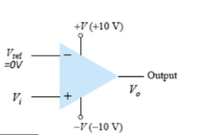

5.b.5 Theoretical background for the experiment/validation of the experiment:
The zero crossing detector circuit is an important application of the op-amp comparator circuit. It can also be called as the sine to square wave converter. Anyone of the inverting or non-inverting comparators can be used as a zero-crossing detector. The only change to be brought in is the reference voltage with which the input voltage is to be compared, must be made zero (Vref = 0V). An input sine wave is given as Vin.

5.b.6 Formulae-required: -----------------

5.b.7 Step by step procedure to carry out experiment:
- Electrical connections are made as shown in the circuit diagram.
- Give input voltage sine wave and observe the square output waveform and its voltage swing
5.b.8 Table of observation:

Vin | Frequency | Vsat | -Vsat
0.5V | 1KHz | 10V | -10V
1.5V | 1KHz | 10V | -10V
2.5V | 1KHz | 10V | -10V

5.b.9 Specimen calculation: --------------

5.b.10 Nature of graph:
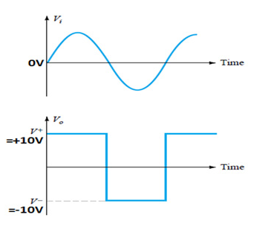

5.b.11 Circuit diagram from the tool:

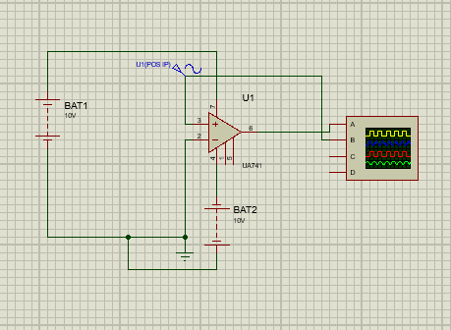

5.b.12 Output waveforms obtained from the simulation tool:
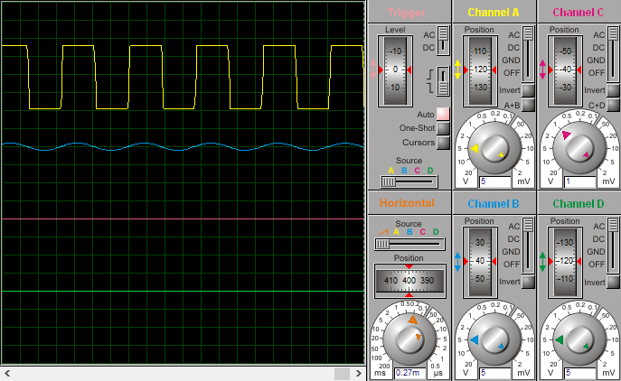
5.b.13 Conclusion of the experiment:
The zero crossing detector circuit is an open loop square wave generating circuit using a sine wave input. The output value is 0 exclusively when the input is 0. For all other cases the circuit gives Vsat or –Vsat as the output

5.b.14 Drawbacks and a solution
In some applications, the input Vin may be a slowly changing waveform, (i.e) a low frequency signal. It will take Vin more time to cross 0V, therefore V0 may not switch quickly from one saturation voltage to the other. Because of the noise at the op-amp‘s input terminals the output V0 may fluctuate between 2 saturations voltages +Vsat and –Vsat. Both of these problems can be cured with the use of regenerative or positive feedback that cause the output V0 to change faster and eliminate any false output transitions due to noise signals at the input. Inverting comparator with positive feedback . This is known as Schmitt Trigger

5.c.1 Title of the Experiment: Full wave precision rectifier

5.c.2 Objective of the Experiment: Implement a full wave precision rectifier and obtain the output waveform
Input = 3sin2π*10³ t

5.c.3 List of Component / Equipments:

Sl.No | Components/Equipments | Specifications | Quantity
1 | Regulated DC | 0-30V, 2A | 02
2 | CRO | 80 Vpp/20MHz | 01
3 | +12V and -12V power pack |  | 01
4 | Op-Amplifier | µA-741 | 02
5 | Resistor | 1K ½ watt | 05
6 | Diodes | 1N4001 | 02
7 | Function generator | 0-1MHz | 01

a

5.c.4 Experimental setup:
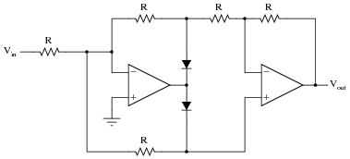

5.c.5 Theoretical background for the experiment/validation of the experiment:
The Precision Full Wave Rectifiers circuits accept an ac signal at the input, inverts either the negative or the positive half, and delivers both the inverted and noninverted halves at the output
The operation of the positive full wave rectifier is expressed as
Vo=|Vi|
5.c.6 Formulae-required: ----------------

5.c.7 Step by step procedure to carry out experiment:
- Electrical connections are made as shown in the circuit diagram.
- Give the input sine wave from the inverting pin
- Observe the rectified output
5.c.8 Table of observation:

Vin | Frequency | Time period | Output Voltage
3V | 1KHz | 1ms | 3V

5. c.9 Specimen calculation: -----------

5.c.10 Nature of graph:
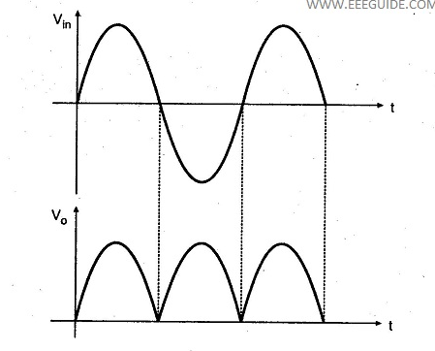
5.c.11 Circuit diagram from the tool:

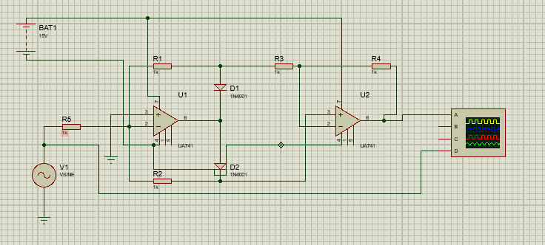

5.c.12 Output waveforms obtained from the simulation tool:

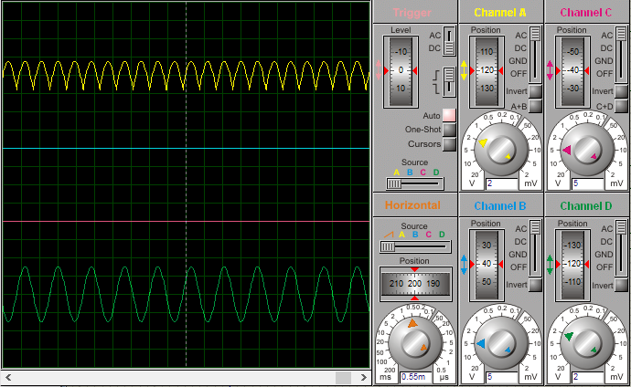

5.c.13 Conclusion of the experiment:
The precision rectifier, also known as a super diode, is a configuration obtained with an operational amplifier in order to have a circuit behave like an ideal diode and rectifier. It is very useful for high-precision signal processing. With the help of precision rectifier the high-precision signal processing can be done very easily

Experiment No: 6
6.a.1 Title of the Experiment: Wien bridge oscillator

6.a.2 Objective of the Experiment:
To Design and implement a Wien bridge oscillator with a cutoff frequency of 3 KHz
Deliverables
- Design of circuit indicating the values of resistors/capacitors wherever applicable

- Rigged up circuit in the simulation tool.
- Explanation of the circuit.
- Output waveform with relevant tabular column
Input waveform can be assumed wherever applicable. Please provide the value of input waveform. Power Supplies for all the circuit +V_{CC}=-V_{EE}=12V

6.a.3 List of Component / Equipments:

Sl.No | Components/Equipments | Specifications | Quantity
1 | Regulated DC | 0-30V, 2A | 02
2 | CRO | 80 Vpp/20MHz | 01
4 | +12V and -12V power pack |  | 01
5 | Op-Amplifier | µA-741 | 01
6 | Resistor | 5.7K ½ watt  1K ½ watt  2K ½ watt | 02  01  01
1 | Capacitors | 0.01uF | 02
8 | BNC Probes |  | 02

6.a.4 Experimental setup:
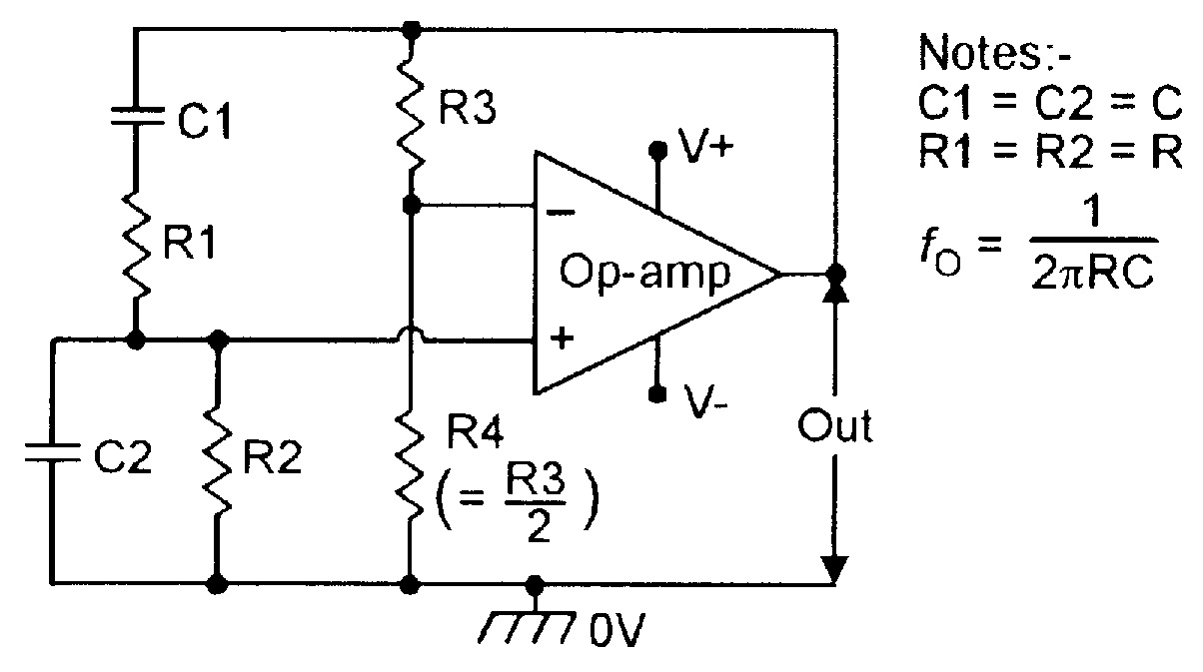
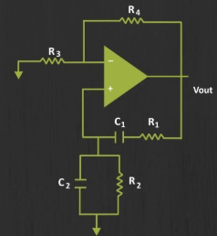

6.a.5 Theoretical background for the experiment/validation of the experiment:
An oscillator is circuit that produces periodic electric signals such as a sine wave or square wave. The application of oscillator includes sine wave generating local oscillator for synchronous receiver etc. An oscillator consists of amplifier and a feedback.
Active device: Amplifier
R-C, L-C combination: Feedback
This oscillator is a low frequency oscillator. The Wien bridge oscillator op-amp is used as the oscillator circuit and it is working like a non inverting amplifier. Hence the feedback network is got given to any phase shift. The circuit is observed like an Wien bridge on RC series network of one arm and the parallel RC network in for another arm. The resistor Ri and Rf are connected to the left two arms.

6.a.6 Formulae-required:

Cutoff frequency fc=1/(2πRC) (Because,R1=R2,C1=C2)

Voltage gain = (1+Rf/R1), (Non-inverting amplifier)
Let required gain = 11.
Assume R1=1kΩ.
Therefore Rf=10kΩ.

6.a.7 Step by step procedure to carry out experiment:
- Electrical connections are made as shown in the circuit diagram.
- Observe the frequency, voltage of the output wave on CRO and compare with the values obtained on DMM

6.a.8 Table of observation: ----------- Not applicable -------------
6. a.9 Specimen calculation: fc=3KHz
1/(2πRC)=3000
Assume, C=0.01uF
Then, R=5.3Kohms
The nearest standard value R=5.6kohms

6.a.10 Nature of graph:
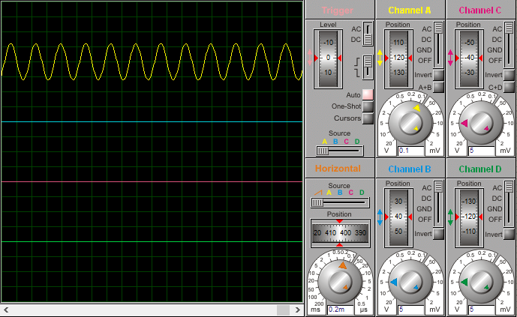

6.a.11 Circuit diagram from the tool:
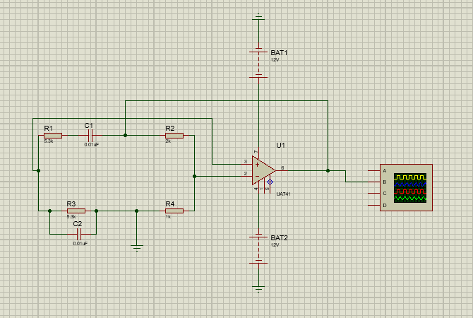

6.a.12 Output waveforms obtained from the simulation tool:

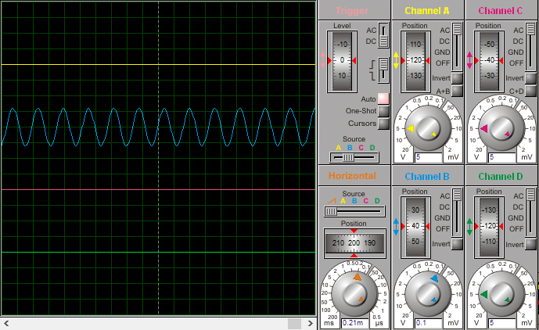

6.a.13 Conclusion of the experiment:
The experiment is performed with respect to the theory and design, a sinusoidal wave is obtained with 3kHz frequency.
Experiment 7
Conduct an experiment to study the effect of damping ratio ζ on performance measures of the prototype second order system using MATLAB.

Deliverables
- Write a MATLAB script to obtain the step response of a prototype second order feedback system given below:
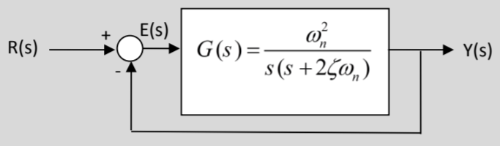

- Find the step response of the system for values of $ω_{n} = 1 rad/sec$ and ζ = 0.1, 0.4, 0.7, 1.0 and 2.0. Plot all the results in the same figure window
- Tabulate the following performance parameters for varying damping ratio.
Performance parameters: Rise time, Delay time, Peak time, %Overshoot, Settling time (4%), and Steady state error.

Code:

k_dc = 1;
w_n = 10;
zeta = [0.1, 0.4, 0.7, 1.0, 2.0];
s = tf('s');
G1 = k_dc*w_n^2/(s^2 + 2*zeta(1, 1)*w_n*s);
G2 = k_dc*w_n^2/(s^2 + 2*zeta(1, 2)*w_n*s);
G3 = k_dc*w_n^2/(s^2 + 2*zeta(1, 3)*w_n*s);
G4 = k_dc*w_n^2/(s^2 + 2*zeta(1, 4)*w_n*s);
G5 = k_dc*w_n^2/(s^2 + 2*zeta(1, 5)*w_n*s);
pzmap(G1, G2, G3, G3, G4, G5)
axis([-3 1 -15 15])
step(G1, G2, G3, G4, G5)
axis([0, 1000 0 8000])

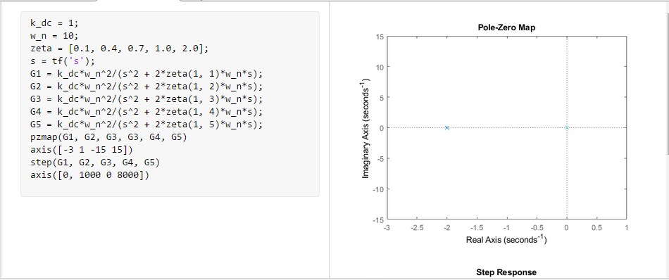

Output :
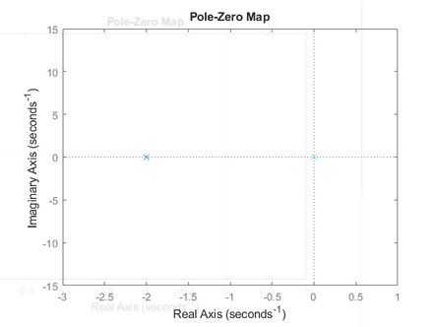

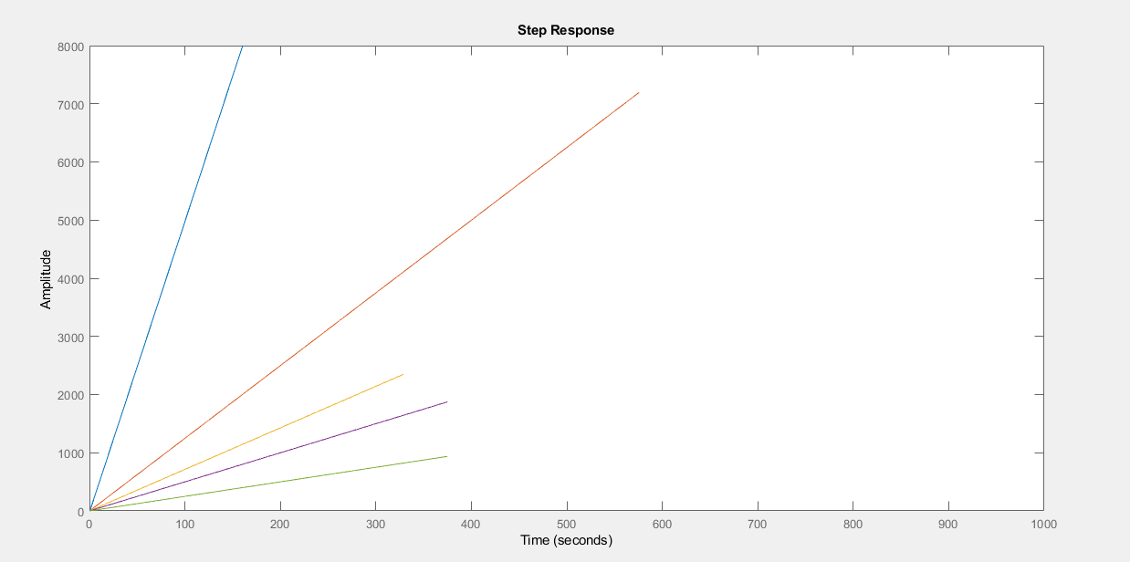

Experiment 8
Conduct an experiment to investigate the characteristics of the each of proportional (P), the integral (I), and the derivative (D) terms of a PID controller/

Deliverables

      - Consider a plant given below to be controlled by a PID controller.
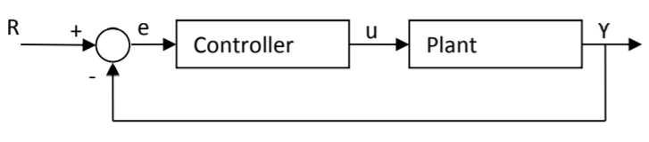
The plant transfer function is: $G_{p}\left(s\right)=\frac{400}{s(s+48.5)}$
And the controller used here is a PID controller having the structure: $K_{p}+\frac{K_{i}}{s}+K_{d}s$. Where, K_{p} is proportional gain, K_{i} is Integral gain and K_{d} is derivative gain. Write a MATLAB script to obtain the unit step response of a open-loop and closed-loop(unity feedback) plant G_{p}(s).
      - Try PI controllers with (K_{p} = 2, 10, 100), and K_{i} = K_{p}/10. Investigate the unit step response in each case, plot all in the same figure window, compare the results and comment.
      - Let K_{p} = 100, K_{i} = 10, and add a derivative term with (K_{d} = 0.1, 0.9, 2). Investigate the unit step response in each case, plot all in the same figure window, compare the results and comment.

- 1. Unit step response by an open loop control system:

Code:
s = tf('s');
p = 400/(s^2 + 48.5*s);
step(p);

Output:
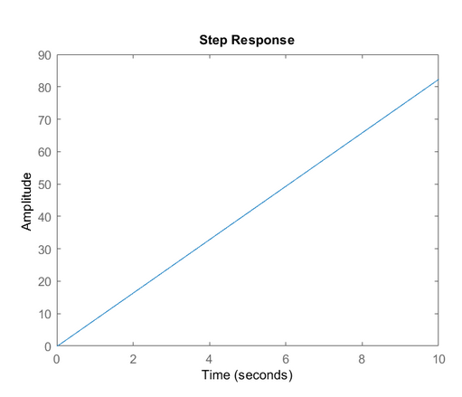

- 2. With Kp=2

Code:

s = tf('s');
P=400/(s^2 + 48.5*s)
Kp = 2;
Ki = Kp/10;
C = pid(Kp,Ki);
T = feedback(C*P,1);

t = 0:0.01:2;
step(T,t)

s = tf('s');
P = 400/(s^2 + 48.5*s);
Kp = 2;
Ki = Kp/10;
C = pid(Kp,Ki);
T = feedback(C*P,1);
t = 0:0.01:2;
step(T,t)

Output:
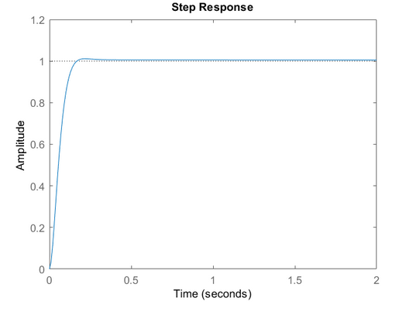

- With Kp=10
Code:
s = tf('s');
P=400/(s^2 + 48.5*s)

Kp = 10;
Ki = Kp/10;

C = pid(Kp,Ki);
T = feedback(C*P,1);

t = 0:0.01:2;
step(T,t)

s = tf('s');
P = 400/(s^2 + 48.5*s);
Kp = 10;
Ki = Kp/10;
C = pid(Kp,Ki);
T = feedback(C*P,1);
t = 0:0.01:2;
step(T,t)

Output:
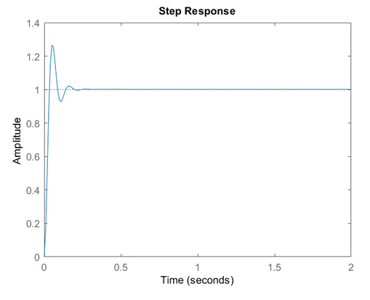

- With Kp=100
Code:
s = tf('s');
P=400/(s^2 + 48.5*s)

Kp = 100;
Ki = Kp/10;
C = pid(Kp,Ki);
T = feedback(C*P,1);

t = 0:0.01:2;
step(T,t)

s = tf('s');
P = 400/(s^2 + 48.5*s);
Kp = 100;
Ki = Kp/10;
C = pid(Kp,Ki);
T = feedback(C*P,1);
t = 0:0.01:2;
step(T,t)

Output:
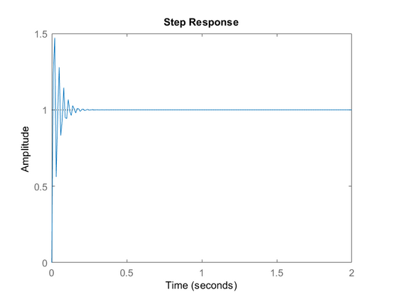

8.3:

- With Kd=0.1
Code:
s = tf('s');
P=400/(s^2 + 48.5*s)

Kp = 100;
Ki = 10;
Kd = 0.1;
C = pid(Kp,Ki,Kd);
T = feedback(C*P,1);

t = 0:0.01:2;
step(T,t)
s = tf('s');
P = 400/(s^2 + 48.5*s);
Kp = 100;
Ki = 10;
Kd = 0.1;
C = pid(Kp,Ki,Kd);
T = feedback(C*P,1);
t = 0:0.01:2;
step(T,t)

Output:
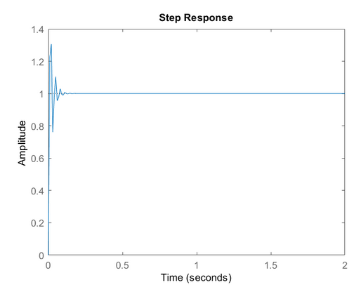
- With Kd=0.9
Code:

s = tf('s');
P=400/(s^2 + 48.5*s)

Kp = 100;
Ki = 10;

Kd = 0.9;
C = pid(Kp,Ki,Kd);
T = feedback(C*P,1);

t = 0:0.01:2;
step(T,t)

s = tf('s');
P = 400/(s^2 + 48.5*s);
Kp = 100;
Ki = 10;
Kd = 0.9;
C = pid(Kp,Ki,Kd);
T = feedback(C*P,1);
t = 0:0.01:2;
step(T,t)

Output:
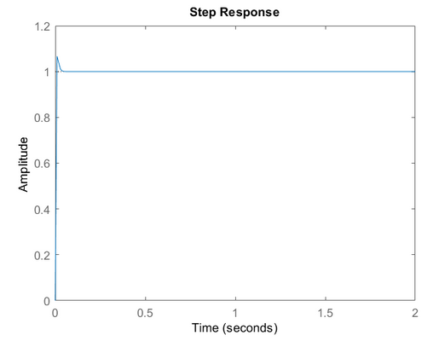
- With Kd=2

Code:
s = tf('s');
P=400/(s^2 + 48.5*s)

Kp = 100;
Ki = 10;
Kd = 2;
C = pid(Kp,Ki,Kd);
T = feedback(C*P,1);

t = 0:0.01:2;
step(T,t)

s = tf('s');
P = 400/(s^2 + 48.5*s);
Kp = 100;
Ki = 10;
Kd = 2;
C = pid(Kp,Ki,Kd);
T = feedback(C*P,1);
t = 0:0.01:2;
step(T,t)

Output:
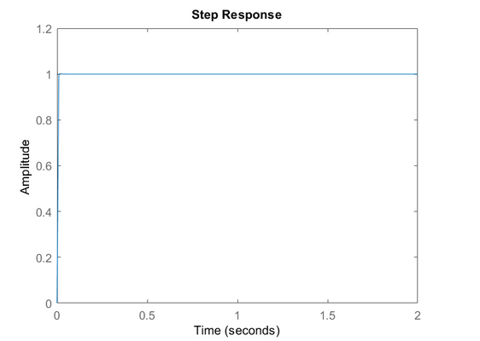s

STRUCTURED ENQUIRY:

Measurement of Opamp parameters
Objective of the Experiment: To verify the electrical parameters of µA741IC Op-amp. Op-amp characteristics.

The Operational Amplifier (OPAMP) is a key building block in analog integrated circuit design. The OPAMP is composed by several transistors and passive elements(resistors and capacitors) and arranged such that its low frequency voltage gain is very high. An ideal op-amp draws no current from the source and its response is also independent of temperature but the practical op-amp draws the current from the source into its input terminals. Also the two inputs respond differently to current and voltage due to mismatch in transistors.

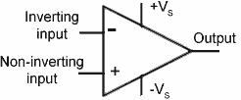

Figure a. Symbol of Opamp
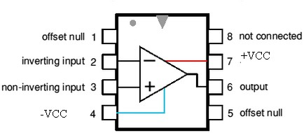

Figure . b Pin configuration of 741 IC Practical Characteristics of 741 IC
Experimentally find the characteristics of opamp 741 IC , compare the measured value by referring to the data sheet of opamp 741 IC and list the values of the opamp characteristics in the following Table a.

Table a. Data sheet and measured value of opamp 741 IC characteristics
S. NO | Characteristics | Data sheet value | Measured Value
1. | Input bias current | 500nA | 520nA
2. | Input offset current | 200nA | 220nA
3. | Input offset voltage | 15mV | 18mV
4. | Slew rate | 0.5V/uS | 0.6V/uS
5. | Input voltage range | ±12V | ±12V
6. | Output voltage ranges | ±10V to ±13V | ±10V to ±13V
7. | Input resistance | 2M ohm | 2M ohm
8. | output resistance | 75 ohm | 78 ohm
9. | CMRR | infinite | infinite
10. | SVRR/ PSRR | 115 db | 135 db

Input bias current and Input offset current

The input bias current is the average value of base currents entering into the

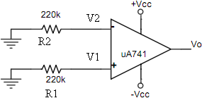
terminals of an op-amp.The741op-amps have input bais current of 500nA.The 741 op-amps have input offset current of 200nA. Figure 1 shows the circuit configuration for measuring the input bias and input offset current.
Figure 1: Circuit diagram for finding Input bias current and offset current Procedure to measure the Input offset and bias current
- Configurethecircuitasshowninfigure1.
- Connect R1 and R2 resistors to inverting and non inverting terminal of Opamp as per the circuit diagram.[R1 and R2 are directly grounded]
- Provide the supply voltage +VCC= 12 V and -VCC= 12V.
- UsingaDMMmeasurethevoltageV1atnoninvertingterminalandV2atinverting terminal with respect to ground.
- Byohm’s law, calculate the input currents o I⁺=V1/R1andIB-=V2/R2
B
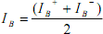
- Find the input bias current IBusing equation[1]

………….. [1]
- Find the input offset current by using equation[2]
520nA………… [2]
- TabulateinputoffsetcurrentandbiascurrentvaluesinTable1.
- Compare the measured value with the value given in the datasheets ,and comment.

- Input offset Voltage
Ideally, the output voltage should be zero when the voltage between the inverting and non inverting inputs is zero. In reality, the output voltage may not be zero with zero input voltage.

This is due to un-avoidable imbalances, mismatches, tolerances, and so on inside the op-amp. In order to make the output voltage zero, we have to apply a small voltage at the input terminals. This voltage is called input offset voltage. Hence , the input offset voltage is the voltage required to be applied at the input for nullifying output voltage. Figure 2 shows the circuit configuration for measuring the input offset voltage.

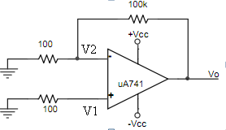

Figure 2: Circuit diagram to measure input offset voltage

Procedure to measure output offset voltage
  - Configure the circuit as shown in Figure2.
  - Provide the supply voltage +VCC= 12 V and -VCC= 12V.
  - Measure the DC output voltage at pin no6 using multimeter and record the result in Table2.
  - Calculate the Gain= 100K/100=1000
  - Find the input offset voltage using equation 3 and record the value in Table 2 Vio = Vo /G
Vio=Vo/1000 = 18mV[3]
- Compare the measured value with the value given in the datasheets, and comment.

- Slew rate
Among all specifications affecting the cooperation of the op-amp, slewrate is the most important because it places a severe limit on a large signal operation. Slew rate is defined as the maximum rate at which the output voltage can change. The 741 op-amp has a typical slew rate of 0.5volts per micro second(V/µs).This is the ultimate

speed of a typical 741;its output voltage can change no faster than 0.5V/µs. If we drive a 741 with large step input, it takes 20µs (0.5 V/µsX10V) for the output voltage

to change from 0 to 10V. Figure 3 shows the circuit configuration for measuring the slewrate.

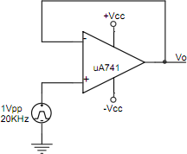
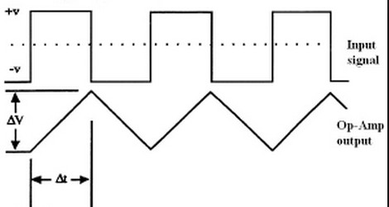

Figure3.aCircuitdiagramtomeasureslewrateFigure3.bOutputwaveformshowing ΔV /ΔT

Procedure for measuring Slew rate.
- Configure the circuit as shown in Figure3.a
- Provide the supply voltage +VCC= 12 V and -VCC= 12V.
- Using an AFO, provide a 1Vpeaktopeak squarewave with a frequency of 10KHz to the non inverting terminal of Opamp. Vary the input frequency and observe the outputusingCROasshowninfigure3.b.
- Measure the voltage change ΔV and time change ΔT of the output waveform. RecordtheresultsinTable3.
Calculate the slew rate using equation4

- SR = ΔV/ΔT= 0.6V/uS[4]
- Compare the measured value with the value given in the datasheets,and comment.
- Input and output voltage ranges
Input voltage range is the maximum positive and negative input voltage applied to the op-amp for undistorted output.
Output voltage range is the maximum positive and negative undistorted output voltage of the opamp. Figure4.as hows the circuit configuration for measuring the input volatge range.

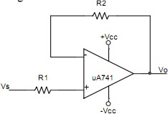

Figure 4. a Circuit for measuring the input volatge range.

Procedure for input voltage range
- AssemblethemeasuringcircuitasshowninFigure4.awithR1=R2=100kΩ.
- Provide the supply voltage +VCC= 12 V and -VCC= 12V.
- Provide Vs=±5V,1kHz sinusoidal input, Observe voltage sat the non-inverting input terminal and output terminal simultaneously using CRO.
- Increase the input signal amplitude until output voltage gets distorted .Measure the positive and negative input voltage peak values.This gives the op-amp input voltage

range. [For 741 Ic input voltage range is +13 V max and – 13 V Min].
- Comparethemeasuredvaluewiththevaluegiveninthedatasheets,andcomment.

Procedure for output voltage range
- Configuretheinvertingamplifiercircuitasshowninfigure4.b.
- Provide the supply voltage +VCC= 12 V and -VCC= 12V.
- ConnectRinbetweenthesourceandinvertinginput.Groundthenon-invertinginput.
- ChooseRin=10kΩ,Rf=100kΩ.
- Using an AFO, provide a 1V peak to peak sine wave with a frequency of 1 KHz, increase the input voltage in stepts of 1V till the output volatge of an opamp saturates.
- Measure the positive and negative output voltage peak values. This gives the op- amp output voltage range. [For 741 Ic Output volatge range is +Vsat< + VCC and
-Vsat <-VCC]
- TabulatethevaluesofinputvoltageandoutputvoltagerangeinTable4.
- Comparethemeasuredvaluewiththevaluegiveninthedatasheets,andcomment.

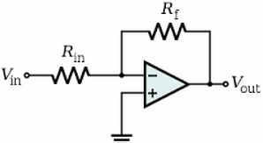

Figure 4. bCircuit for measuring the output volatge range.
- Input and Output Resistances ,Rin and Ro

The input resistance looking into the two input terminals of the op-amp is ideally infinity. This means that the device draws no current. For a practical 741 op-amp, the input resistance is about 2MΩ. The output resistance on the other hand is ideally zero. For the 741,it is about 75 ohms. This makes the op-amp ideal for driving low resistance loads. Figure 5 shows the circuit configuration for measuring the input and output resistance.

Procedure to measure input and output resistance
- ConfiguretheVoltagefollowercircuitasshowninfigure5.
- Provide the supply voltage +VCC= 12 V and -VCC= 12V.
- ConnectAFOandsuppyViof1VppandmeasurethecurrentIatthenoninverting terminal of theopamp.
- CalulateinputresistancebyRin=Vi/I.
- Comparethemeasuredvaluewiththevaluegiveninthedatasheets,andcomment.
- Connect the DMM across ouput terminal (6th terminal of opamp)and keep it in resistance mode and measure the ouput resistance. Compare the measured with thevaluegiveninthedatasheets,andcomment.

Common mode rejection ratio(CMRR)
If the left terminals of R1and R3 are lifted off ground and driven with a common voltage VCM as depicted in Figure 6 we expect that a true difference amplifier will give VO= 0 regardless of VCM. In practice, VO is likely to be different from zero becauseactualresistorswillfailtosatisfyEq.(1)R4/R3=R2/R1exactly,andalso becauseofopampnonidealities.

Symbol and Pin configuration of 741 IC
Figureb.showsthesymbolofopamp.Figureb.showsthepinconfigurationof741IC, [Dual in linepackage]

An Operational Amplifier is basically a three-terminal device which consists of two high impedanceinputs,pinnumber2istheInvertingInput,markedwithanegativeor“minus” sign, ( - ) and pin number 3is the Non-inverting Input, marked with a positive or “plus” sign ( + ). And pin number 6 is the output port which can both sink and source either a voltage or a current. In a linear operational amplifier, the output signal is the amplification factor, known as the amplifiers gain ( A ) multiplied by the value of the input signal. Pin number 7 and pin number 4 are the terminals for supplying the external DC voltage for proper operation of opamp. Pin number 1 and 5 are used to nullify the offsetvoltageoftheopamp.Pinnumber8isnotconnected.
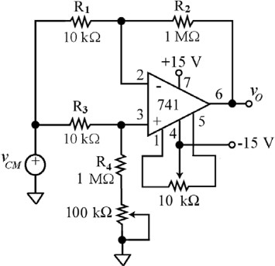
Figure 6. Measuring circuit for CMRR
The ratio VO/VCM is called the common-mode gain.
ACM= Vo
Vcm

IfwedefineVDM=V2−V1inFigure6,thenthegain,thedifferential-modegain ADM=Vo
Vdm

A very important figure of merit of a difference amplifier is its common mode rejection ratio, defined as CMRR= 20log (ADM)
ACM

Procedure for finding CMRR
  - With power off, add to your difference amplifier the 100-kΩ pot as indicated in Figure6.
  - Initially,turn the wiper all the way up so as to short out the pot resistance.
  - Next, apply power,and using Ch.1 of the oscilloscope to monitor VCM, adjust the wave form generator so thatVCMisa100-Hzsinewave alternating between –5V and +5V.
  - Observe VO on CRO, measure the gain ACM=VO/VCM,and calculate the CMRR along with ADM≅100V/V,to find the value of CMRR dB for your difference amplifier.

Power supply rejection ratio(PSSR)
PSSR is the change in the input offset voltage with change in the power supply.
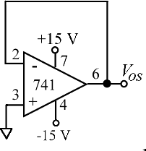

Figure7.CircuitformeasuringP

Procedure for measuring PSSR

  - With power off, assemble thecircuitofFigure.7.

  - Apply power, and measure the output with your digital multi-meter configured as a DC voltmeter.
  - Given that the op amp is working as a voltage follower, the output reading is simply the input offset voltageVOS1.
  - Turn power off, configure the circuit again as in Figure 8, and lower the supply voltagesfrom±15Vto±10V,thus effecting power-supply changeΔVS=5V.
  - Apply power, measure the new value of VOS2,and find the difference ΔVOS,
  - ΔVOS= VOS1_VOS2
  - Finally, find
  - PSRR≅|ΔVOS/ΔVS|, in μV/V. Compare with the value given in the datasheets, and comment.

